Business Intelligence in the Finance Industry

EXPLORING LENDING CLUB LOAN DATASET

maoyi song

2019

## Exploratory Data Analysis

**Data Preparation (Tableau)**

* Change data type of **Issue D** to **Date.**
* Split the column of **Term** “36 months”, “60 months”to number **36 and 60.**
* Group “Charged off, Late (31-120 days), Late (16-30 days), In Grace Period, Does not meet the credit late, Default” to **Bad Loan,** “Does not meet the credit Full Paid, Full Paid, Current” to **Good Loan.**

**Feature Distribution**

What we should know:

* **Which year** we issued most loan and fund.
* **Prediction** for the next year (2019).
* What **amount mostly issued**.

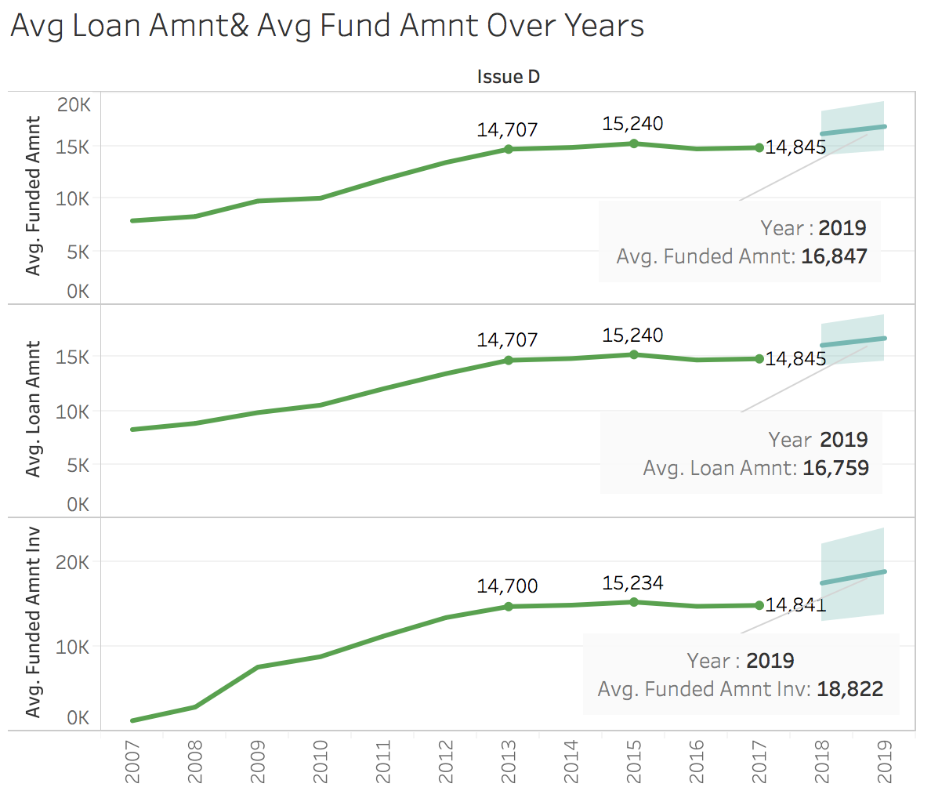

Summary:

* The mostly issued loan amount is between **100,000 to 200,000.**
* Based on the history data, the prediction for average loan amount is 16,759 average funded amount is 16,847, and average of investor requested fund amount is 18,822 **in 2019**.
* **The year of 2015** was the year were most loans were issued.
* The distribution for these three graphs are similar, which means **most qualified borrowers are going to get the loan they had applied for.**

**Types of Loans**

What we should know:

* Combine the loan statues into two different groups, **good loan and bad loan**.
* “Charged off, Late (31-120 days), Late (16-30 days), In Grace Period, Does not meet the credit late, Default” to Bad Loan. Others to Good Loan.

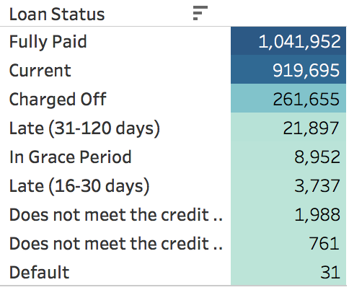 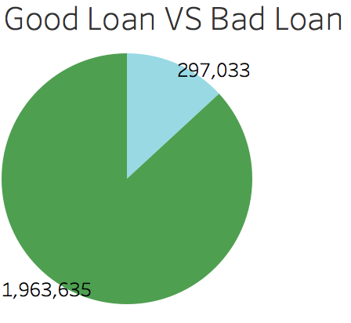

Summary:

* Most of the records are **Fully paid** and **Current active**.
* **Good Loan** are **larger** than Bad Loan.

**Good Loan VS Bad Loan**

What we should know:

* How good loan and bad loan performed **over the years**.
* **Prediction** for the next year(2019).
* **Comparison** of the average interest rate between **good loan and bad loan**.
* More information about **bad loan**.

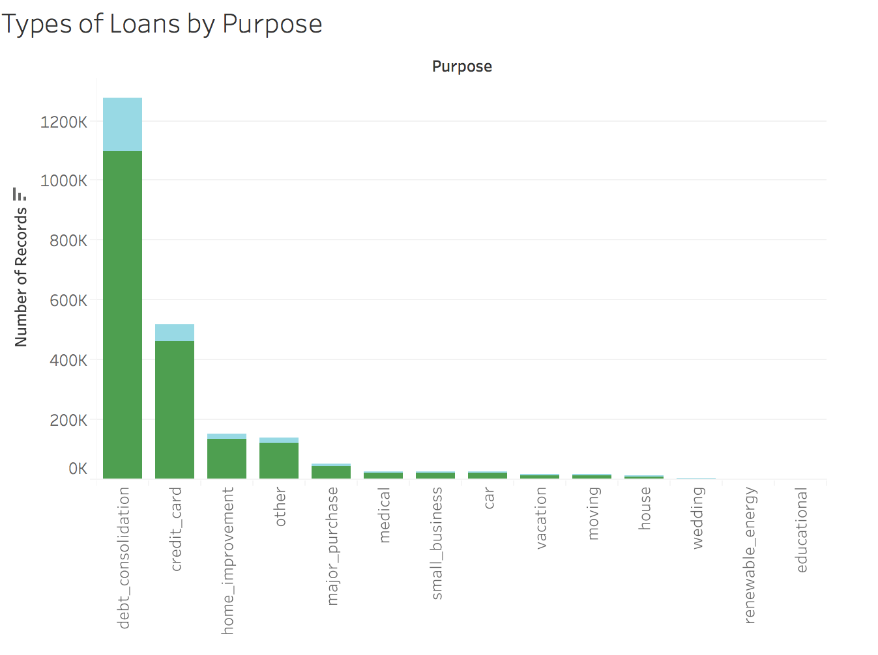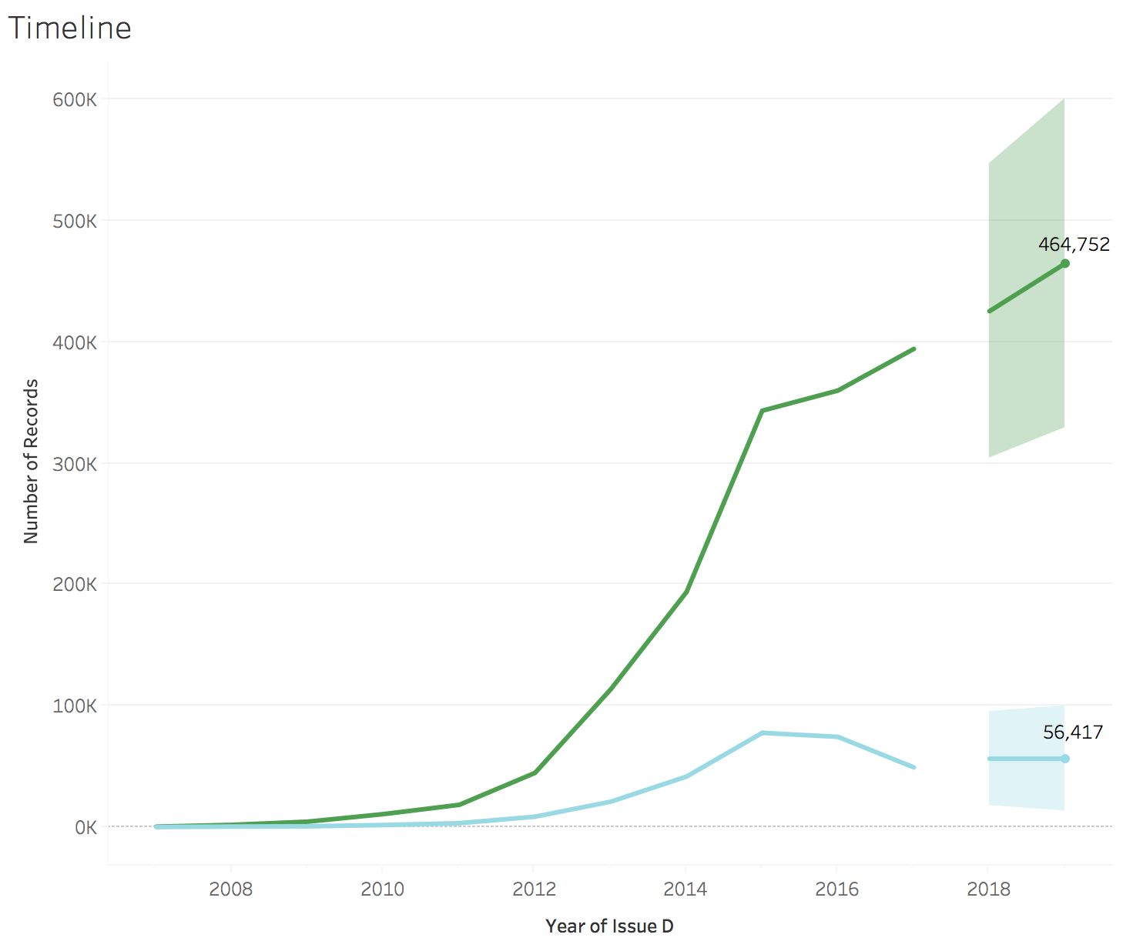

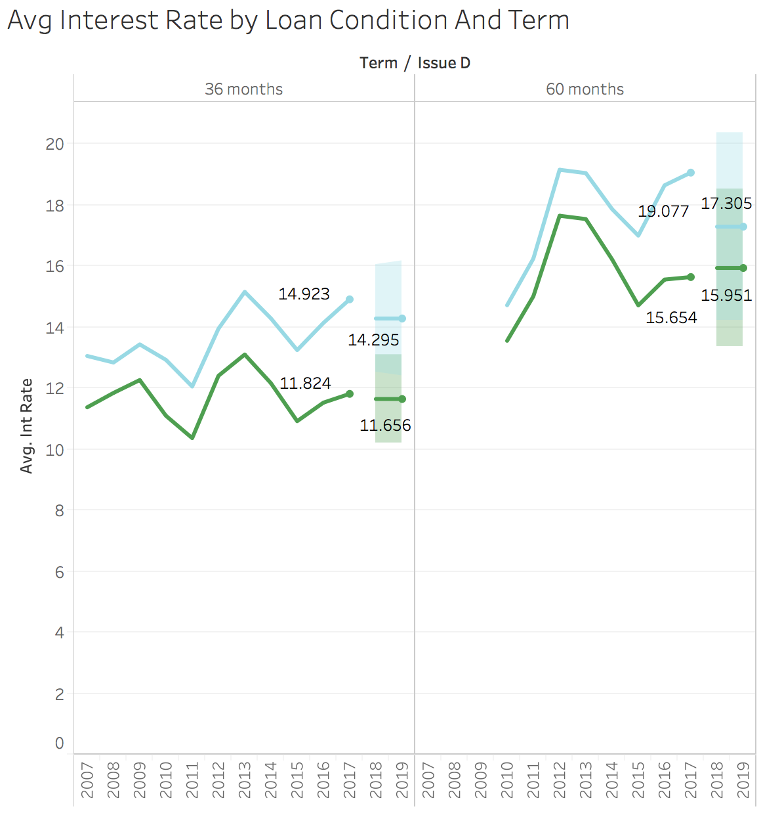

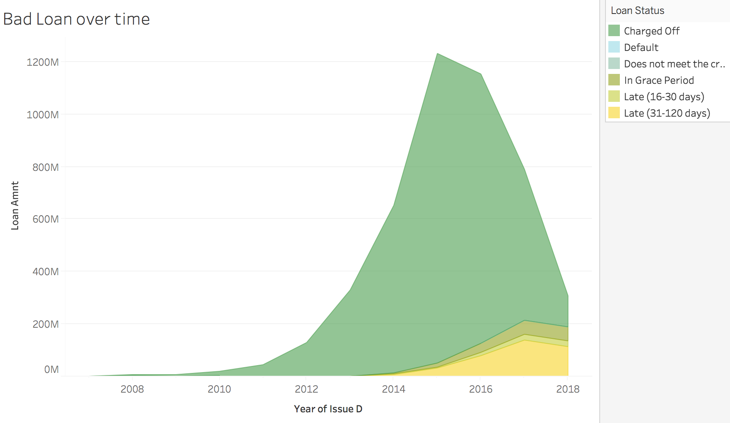

Summary:

* Most of borrower who issued the loan have the purpose of **debt consolidation or credit card.**
* **Good loan** trend to **increasing** fast in the **next year** at amount of 464,752. And, Bad loan will decrease in the next year.
* Most people choose to issued the loan in **60 terms** rather than 30 terms and both bad loans interest rates are higher than good loans.
* For the next year, the good loan’s interest rate should be **decreased** to **17** for 60 terms and **14** for 30 terms. However, the bad loan’s interest rate should stay the same or increase a little bit.
* Most of bad loans are **charged off in 2015.**

**Credit Score and Risk**

What we should know:

* There are 7 different grade which indicated different levels of risk. 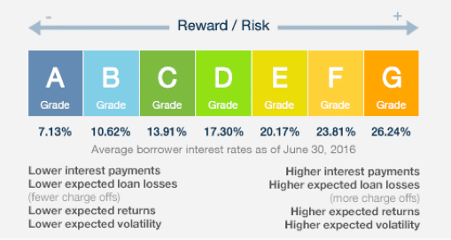
* Which grade has the highest number of issued loan.
* How it performed after we grouped in two different category loan.
* Grades among different regions.

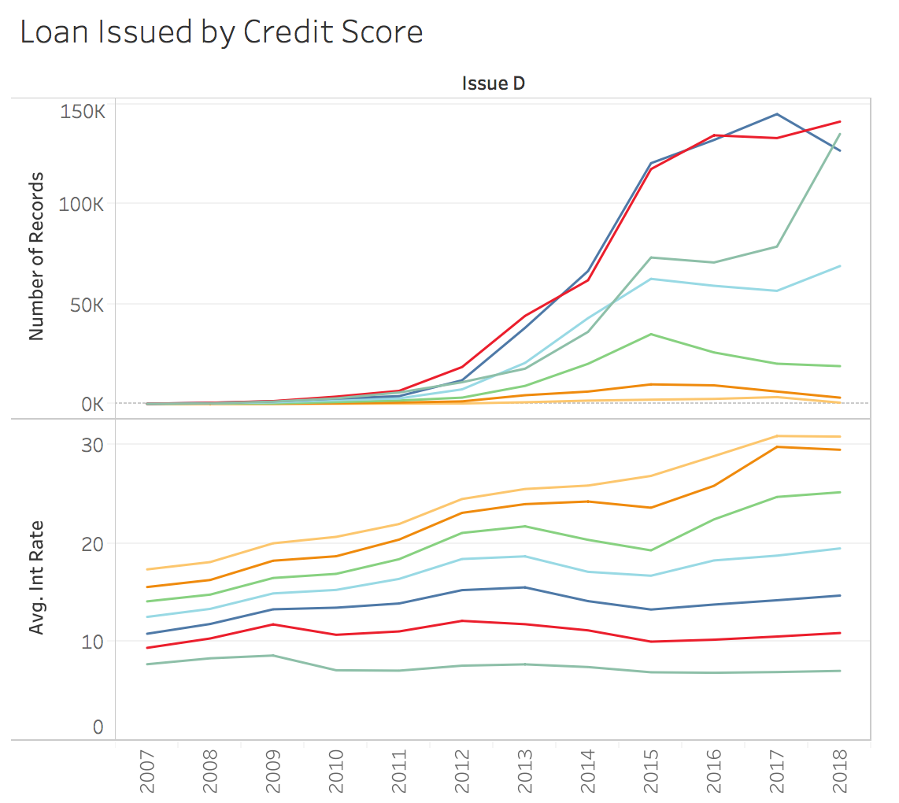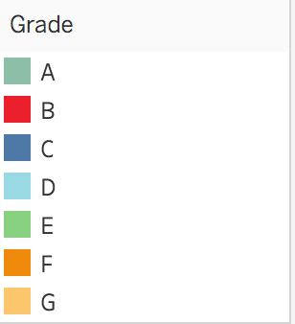

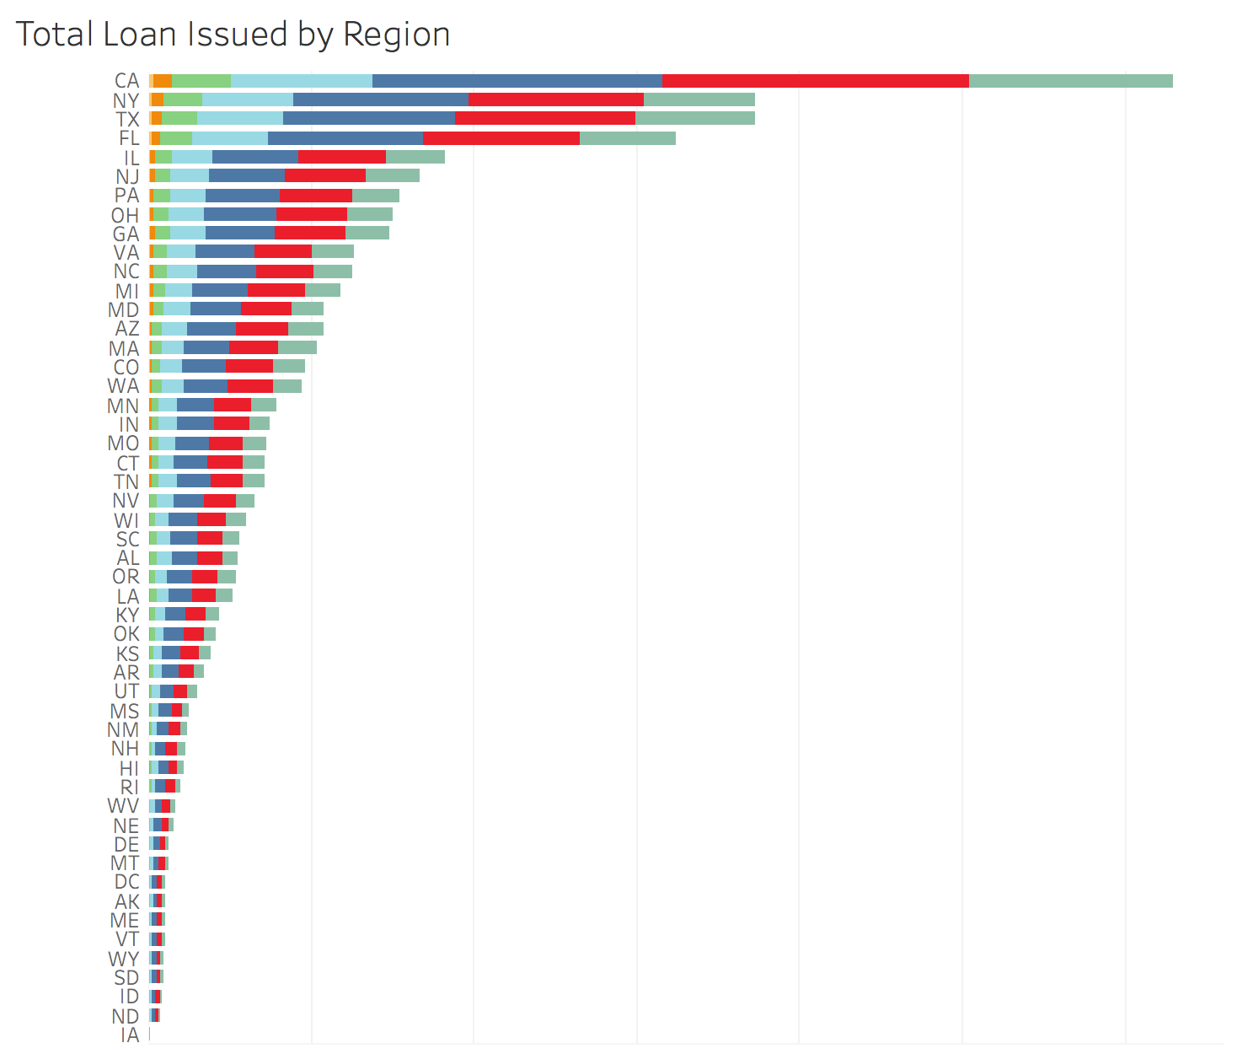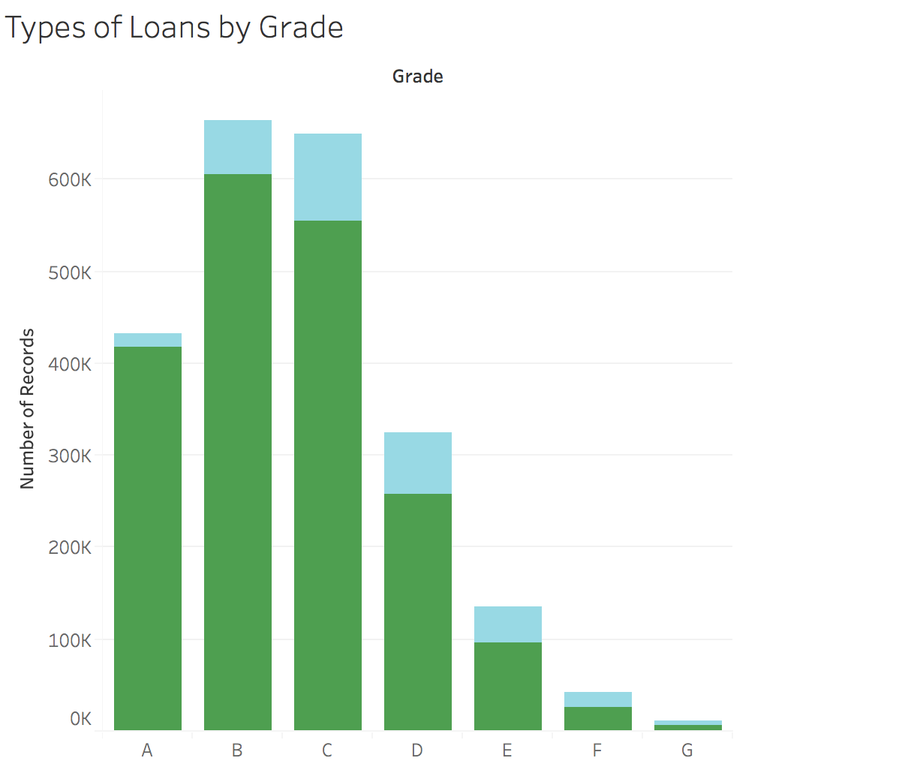

Summary:

* The **gap** of **average interest rate** between **D, E, and F** is **huge** in **2017-2018**. And **E and F** interest rate has **increase**d fast from 2015.
* **Most people** issued the loan in grade **B and C**, especially in the state of **CA and NY**.
* People who issued the loan at **A** grade has a big **increase** from 2017.
* People who issued the loan at **E, F and G** grades has **decreased** from 2017.
* Most of loan are in good condition, and **grade C** has the **highest bad loan percentage** compare to others.

**Region Contribution**

What we should know:

* Which state has the highest average annual income
* What average interest rate for each state
* Bad loan vs good loan among the states

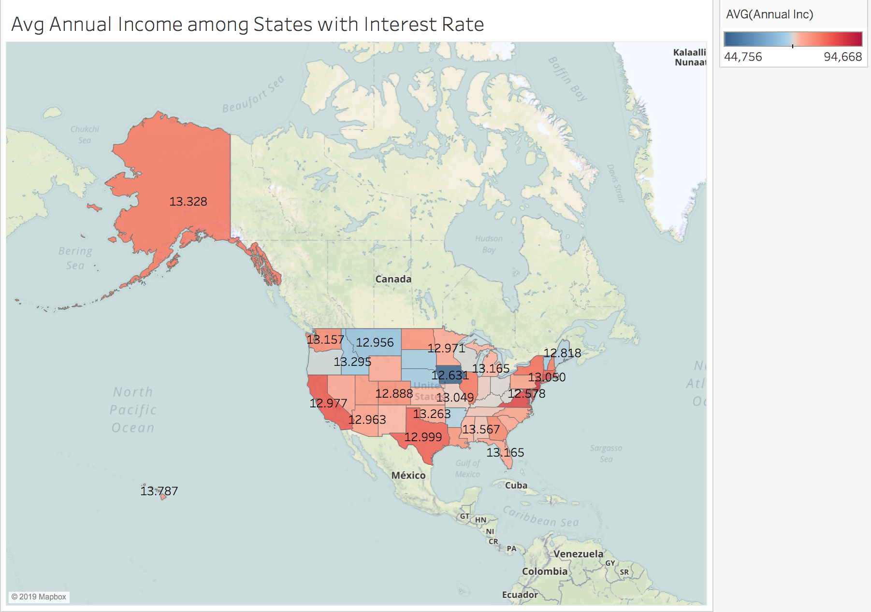

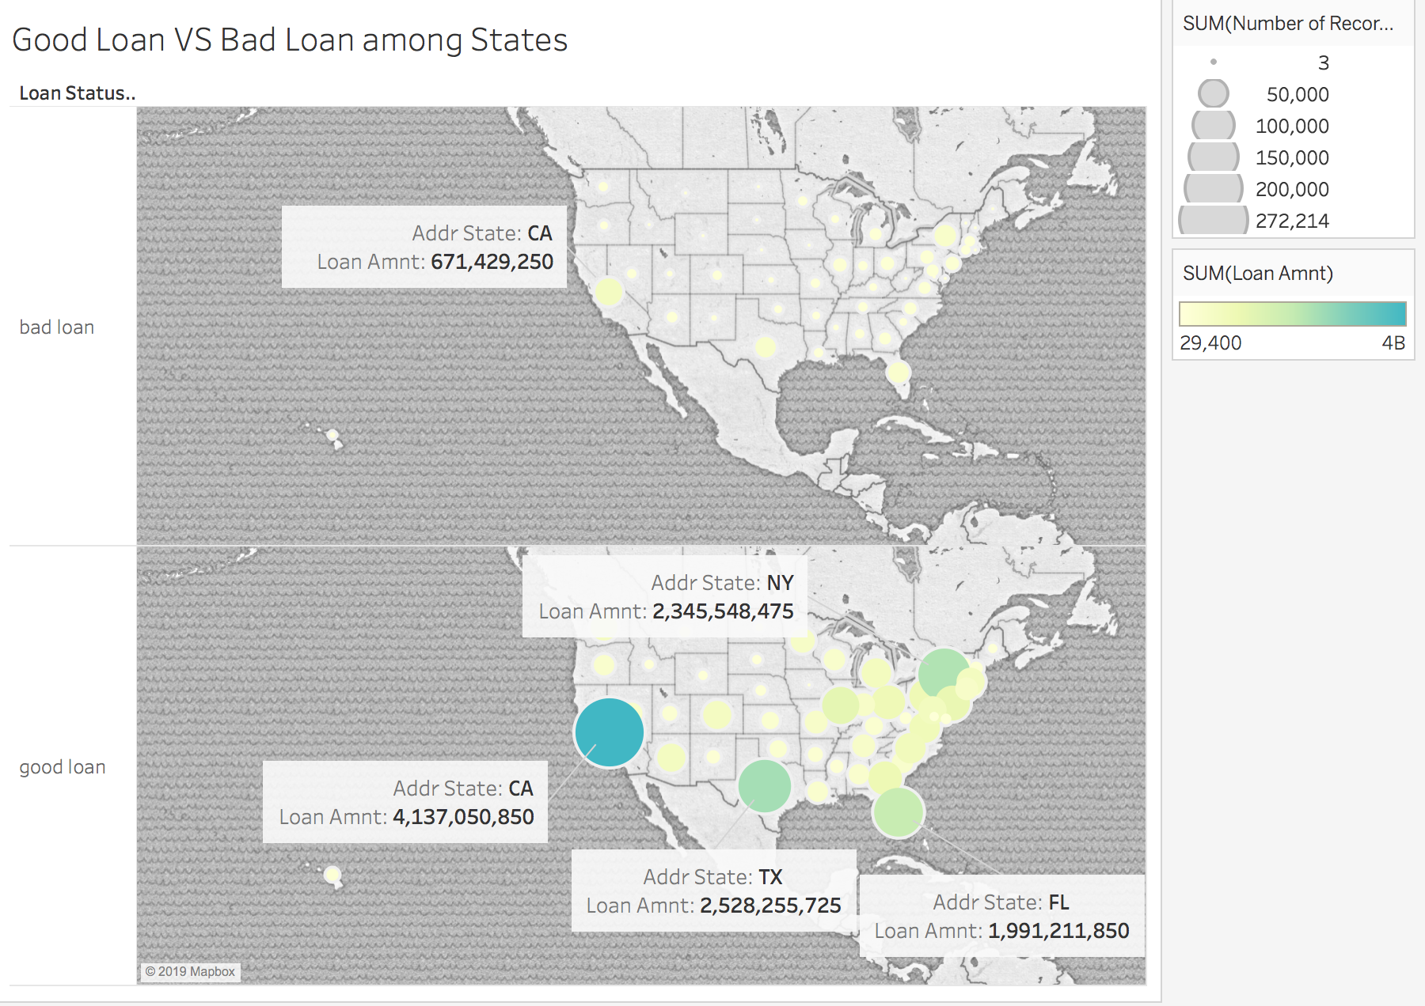

Summary

* **New York** and **California** has the highest average annual income.
* Each state has different interest rate, in **Seattle**, people receive the interest rate over **18**.
* **CA** has the highest amount of good loan, and followed by **NY, TX** and **FL.**

## Feature Selection and Modeling

1. **Data Mining (Python):**

In Tableau:

* Delete the descriptive, categorical, and discontinuous columns.
* Export data to .cvs file.

In Excel:

* Change A - G to 1-7 in both column of **Grade** and **Sub_Grade**.

In python:

* Drop **Nan** Values in the columns.
* Randomly select **5000** records.

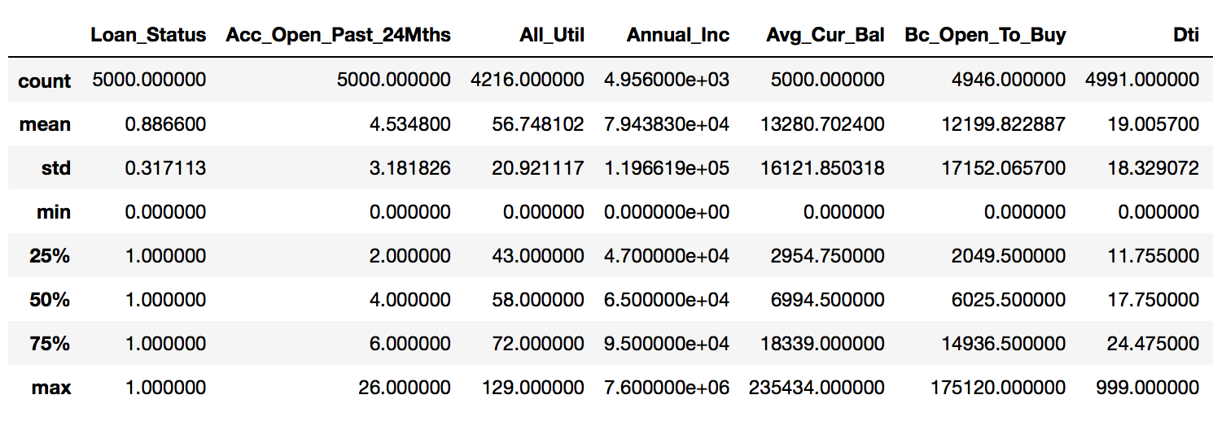

1. **Correlation between Features**

Summary:

* Most of the features are correlated with **Loan_Status**
* Some features are correlated with each other, such as **Grade and Sub_Grade**.

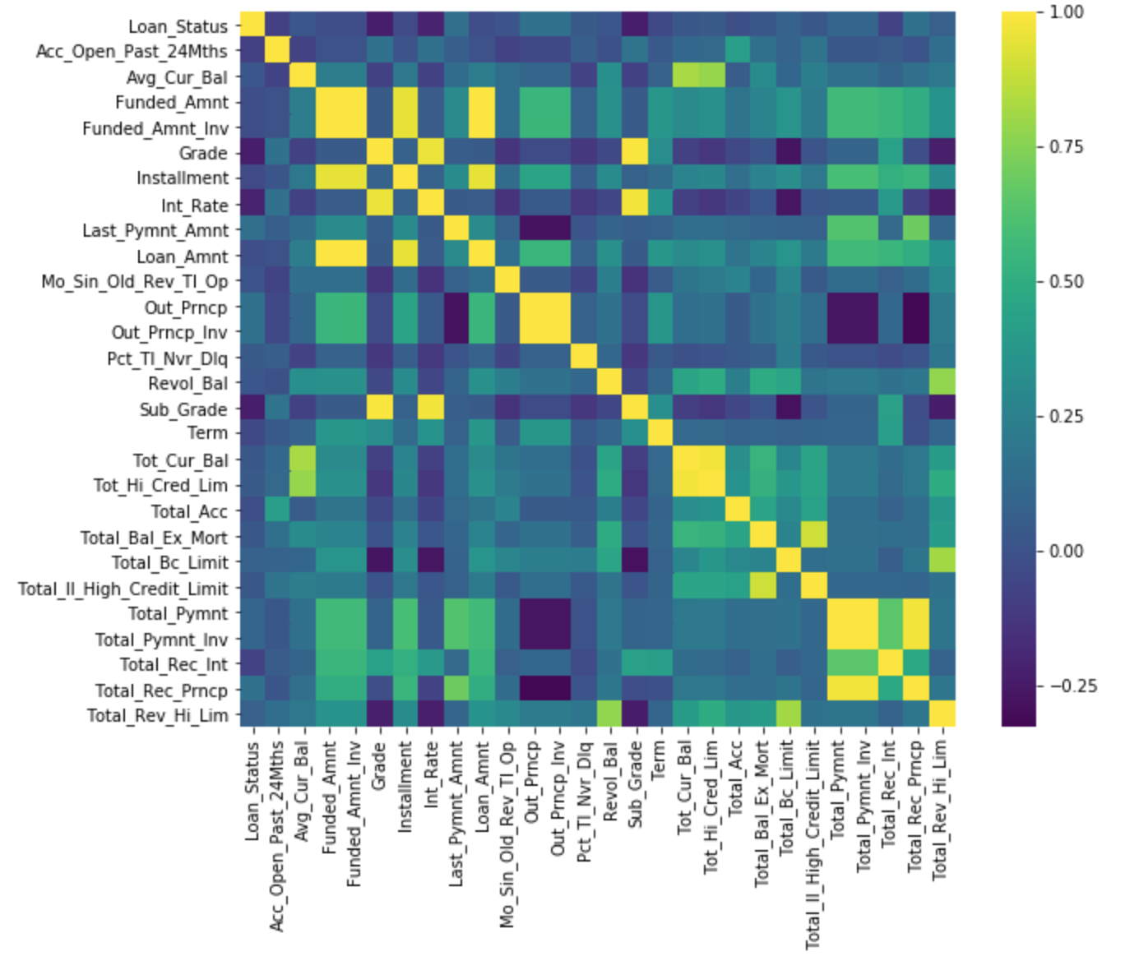

1. **Feature Selection**

Summary:

* Best score 0.55 when choose 19 features.
* Drop the irrelevant features.

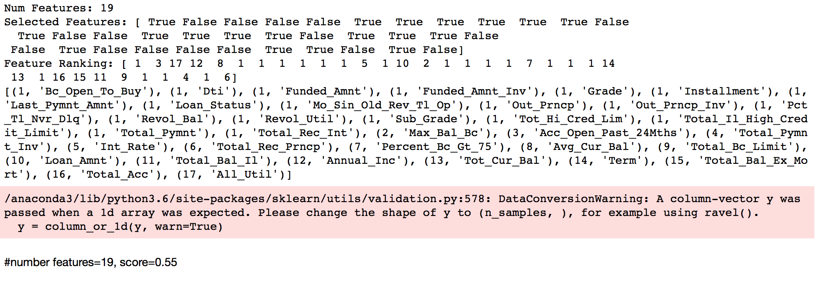

1. **Random Forest Modeling & ROC Score**

Summary:

* Highest score with **Random Forest** **Model** compare with others.
* Best score with Random Forest Model with **Max depth=15.**
* **Best model** when cv=10, accuracy score=0.958, precision= 0.955 and recall=0.998.
* ROC AUC=0.848, model has around **85%** of accuracy.

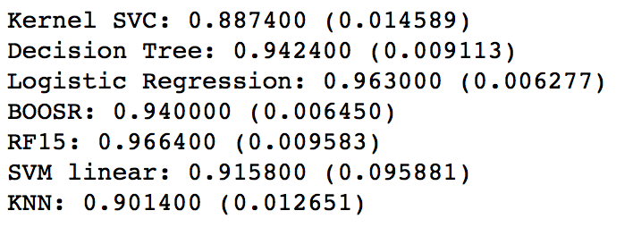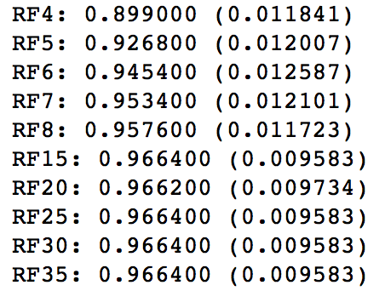

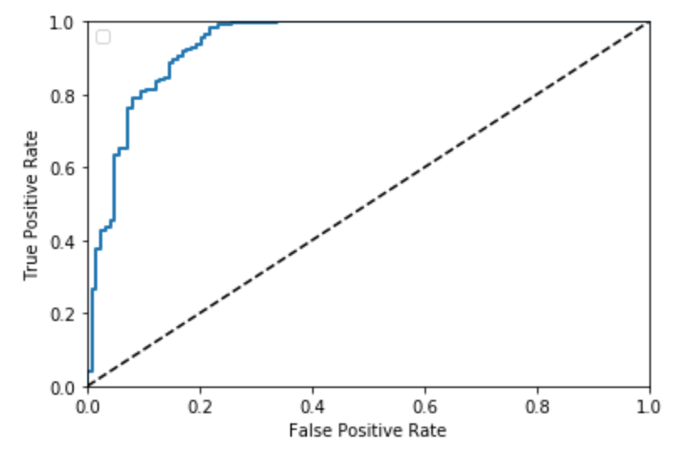

Recommendations

    Based on the EDA, we can see the most qualified borrowers are going to get the loan they had applied for. The prediction for average loan amount is 16,759 average funded amount is 16,847, and average of investor requested fund amount is 18,822 in 2019. The total loan amount and funded amount will increase in the next year. In order to increase the percentage of total good loans or the people who issued loan, we can:

* Pay attention to the people who issued the loan on the purpose of debt consolidation, has been charged off or marked as late, choose the loan on C grade in 60 term.
* Decrease the interest rate for the loan in grade of D.
* Decrease the interest rate of good loan in the next year for both 36 and 60 terms.
* Re-assign the average interest rate over states. For example, decrease the average interest rate in Settle in order to increase the total amount of issued loans.
* Build the random forest model to predict future loan status for each portfolio.